**IoT – Integrated Wearable Device for**

**Enhancing Women’s Security**

|  |  |
| --- | --- |
| 1 Adhiyamaan, 2 Gugan,  3 Gokulnath  Students Dept. of ECE,  *Jeppiaar Institute of Technology*,  *Chennai, India* | 4 Prof. Dr. D. Kumutha  Professor Dept. of ECE,  *Jeppiaar Institute of Technology,*  *Chennai, India* |

***Abstract*—** The goal of this project is to develop tools and systems that improve women's safety in a variety of situations by utilizing the Internet of Things' connectivity and data processing power. Today's society places a high priority on women's safety, and the development of IoT technology presents a viable answer. The goal of the project is to create a system that can track loved ones in real time, record blood pressure and temperature, identify any risks, and notify emergency services. It uses wearable technology for personal tracking and Internet of Things sensors to monitor the surroundings. Data integrity and security are prioritized during the collection, storing, and processing phases of a secure cloud infrastructure. Through data analysis, machine learning algorithms find anomalies and possible safety hazards. The gadget has an adaptable alert system that can communicate via email or SMS, ensuring swift responses in emergencies. The system is designed for scalability, integrating with existing safety structures, and undergoes rigorous testing for reliability. The wearable device offers a holistic safety solution and the integration of machine learning ensures proactive threat detection. A user-friendly interface enables easy monitoring and settings management. By combining IoT, cloud technology and machine learning, it aims to create a robust and adaptable safety system, fostering a safer environment for women in various scenarios.

***Keywords—IoT*, IoT-based security devices*, Women Safety,*** **Wearable, , Threat Detection, IoT, Real time tracking, Alert system.**

# **I. INTRODUCTION**

In this twenty-first century, where people are free to do as they like and go to whatever location they choose. A segment of the population, approximately 50% of it, nonetheless faces limitations in their ability to fully live their life. It's true that women are in discussion. Various forms of inequality still affect women. 2015 had over 300,000 reported instances, up 44% over 2011's total of crimes against women, according to the National Crime Records Bureau. As the cornerstone of any economy, they practically shape the destiny of the country. Having previously remained at home to take care of her household responsibilities, she is now managing her career and home at the same time and working alongside males to contribute to economic progress.

Thus, now is the moment to consider their safety, and IoT makes this feasible (Internet of Things). The main answer for the issue can be taken so that the women ought to be allocated with a well-being device that is convenient and guarantees her security. Our project focuses on developing a smart device based on Internet of Things architecture that not only helps women escape their everyday situations but also ensures that they have equality.

IoT stands for Internet of Things, a vast network of networked devices that can be effectively managed remotely without the need for direct human intervention. As time goes on, an ever-increasing amount of devices are becoming connected, and the Internet of Things (IoT) is becoming an essential part of our life that helps us complete daily tasks more quickly, effectively, and in ways that were not before possible. In a perfect world, IoT will modernize future schedules with clever and reliable frameworks that peacefully enhance our way of life while also adapting to the constantly changing necessities. It will enable us to have fully automated systems, which can be used to remove customer obstacles from any security measures and improve the intelligence of our security plans.

This is made feasible by our gadget, which not only complies with all safety regulations but also has the ability to notify the pre-designated contacts in the event of a risky circumstance. The primary goal of this endeavor is to develop a wearable device for women's security. By analyzing physiological signals connected to bodily reaction parameters, this objective is achieved. The body heartbeat, body vibrations, and galvanic skin response are the physiological markers that are studied. This device is programmed to continuously monitor the subject's parameters and take action if any dangerous situations arise. When a person is in danger, their body vitals alter, and a distress algorithm is triggered when these vitals surpass the optimal range. The place of an individual is sent to the desired contacts to get the nearest help possible autonomously. The data is sent to the cloud for the regular health monitoring of an individual. Tactile switches are the additional feature in the gadget which makes it more efficient. The safety device will act as a guardian to the women at all times.

# **II. LITERATURE SURVEY**

# 

We were able to identify the ideal combination of sensors and modules for our suggested model by using the survey that follow.

1. There has been a noticeable increase in crimes against women, and stories of rape, eve-teasing, and molestation in public spaces are common. Nowadays, women's safety is the top priority. It is vitally crucial to develop safety devices that can save lives and shield people from harm in an emergency, especially for women. The smart device for women's safety that uses temperature, pressure, and pulse-rate sensors to automate the emergency warning system and identify potential atrocities using outlier detection is presented in this research. With the woman's GPS coordinates, our technology locates and notifies loved ones without the woman's involvement.
2. The study tackles the growing problem of women's safety, especially in India, and suggests a wearable technology known as Smart Wearable Equipment (SWD) as a remedy. This gadget makes use of Internet of Things (IoT) technology, combining machine learning techniques with features like a GPS sensor and piezo buzzer. When turned on, the SWD notifies contacts of the user's location, phones relatives and law enforcement, and sounds a high-pitched alarm to warn those in the vicinity. It makes use of real-time datasets to increase accuracy and seeks to further improve efficacy through deep learning techniques. The ultimate goal of the SWD is to give women better safety precautions under trying circumstances.
3. In our society, are women incapable of leading independent lives? Every day, especially in big cities, there are a rising number of reports of rapes, physical abuse, and other acts of violence against women. Despite the presence of CCTV, the attacker could not be identified at the time of the attack. The purpose of this article is to empower women to become self-sufficient through the use of technology, hence reducing the amount of crimes against Indian women and girls. The application concept reveals a practical, effective, and portable solution that can help women enjoy safe, independent lives. The Internet of Things uses force-sensitive resistors, impact sensors, LCDs, Bluetooth modules, SIM 800 GSM modules, and other components to bring everything that humanity has created and implemented together.
4. Concerns about women's safety are becoming more and more urgent, both in India and globally. Being unable to react to distress calls in a timely manner is a major problem for law enforcement for a variety of reasons, including not knowing where the incident is or even if a crime is being committed. It can be intimidating for the victim to contact the police in a secure and timely manner. This paper presents WoSApp (Women's Safety App), a smartphone application that provides women with a dependable way to call the police in an emergency, in order to solve these restrictions. By tapping the PANIC button on the app's interface or subtly shaking their phones, users can initiate the emergency call feature. The application instantly transmits a message with the user's position and the pre-selected contacts' information.

[5] One smart watch with GPS is proposed in this paper. In addition, this system includes a voice recognition module, a screaming alarm module, and an electric shock generator module—all of which are helpful for the safety of women. A temperature sensor, a heart rate sensor, and a motion sensor are the three sensors found in the smart band. In addition to monitoring situations in real time, the system can identify women who are in danger. In order to help with appropriate response, this system can determine a person's location and health status.

**III. OBJECTIVE OF THE PROJECT**

The device aims to enhance personal safety through real-time monitoring and alerts for potential threats or emergencies. It's designed to be easily accessible and user-friendly, allowing individuals to carry it at all times without hassle. Prioritizing data security and privacy, encryption and secure data transmission protocols are implemented to protect user information. Seamless integration with existing safety and emergency response systems enables quick and effective responses. Community and user engagement are vital, with feedback and testing essential for refining functionality and usability. Additionally, the project aims to raise awareness about safety issues and promote the adoption of technology-based solutions. In summary, the objective is to create a device that enhances personal safety, improves accessibility, ensures data security, integrates with existing systems, engages with the community, and promotes awareness and education about safety.

**IV. MOTIVATION OF THE PROJECT**

The women's safety wearable sensor project using IoT technology is driven by the urgent need to address rising instances of harassment and assault. It aims to empower women and ensure their safety globally. Key motivations include combating abuse, providing a tool for fearlessness, and innovating in safety solutions. Leveraging IoT technology, the project seeks to create a portable device for real-time monitoring and emergency alerts. Community engagement is crucial for raising awareness and advocating for technology-based solutions. In essence, the project strives to address safety concerns, empower women, innovate in safety, and engage communities for women's safety and empowerment.

**V. EXISTING SYSTEM**

The recognition of women's wearable safety using IoT technology builds upon existing systems to enhance personal security. By integrating IoT sensors into wearable devices, real-time data on the user's surroundings and physical condition can be collected. This data is then processed using machine learning algorithms to recognize patterns indicative of potential threats or emergencies. Leveraging existing systems such as GPS trackers and communication networks enables swift alerting of authorities or designated contacts in case of danger. Additionally, incorporating features like voice recognition or biometric authentication adds layers of security to the wearable device. Overall, this recognition system augments traditional safety measures with IoT technology, providing women with an advanced and proactive means of personal protection.

**VI. PROPOSED SYSTEM**

Many elements and procedures are usually taken into consideration while proposing an IoT-based cloud server-based women's safety management system. These include keeping an eye on both personal and environmental conditions by using a variety of Internet of Things (IoT) sensors and gadgets, such as heart rate monitors and GSM. In order to gather, store, and process data from various devices and guarantee data integrity, security, and accessibility, a cloud server must be set up. By using embedded algorithms, data can be analyzed, safety hazards may be predicted, and anomalous patterns can be found. In order to send SMS alerts and push notifications in the event of a safety issue, it is imperative to develop an alert and notification system. Users may adjust safety settings, control IoT devices, and keep an eye on safety status by designing an intuitive user interface. scalability, ease of upkeep, and updates are vital design considerations for accommodating growing user numbers. Integration with existing safety systems like emergency response services ensures a comprehensive safety solution. Thorough testing and validation are conducted to ensure reliable system functionality, with user training and support provided to ensure effective system utilization and response to safety alerts.

Fig. 1. Block Diagram of the System

The suggested system for the current project is depicted in Fig. 1 above in a very distant way.

Automatic pattern recognition and creation of hazard will be possible for the device. In women's safety gadgets, the input layer is made up of several different sensors. The woman has affixed the sensors to the specific wearable gadget. The modules are activated by sensors, and embedded algorithms are employed for training. Different algorithms in the processing layer that are based on artificial intelligence are connected to the sensors. Women who are threatened and those who are not are used to train the device in real time. While heartbeat and pulse rate readings are intended to be obtained from sensors using existing equipment, there are a variety of reasons why these numbers could fluctuate.   
However, the suggested model involves several fully trained sensors as well as computational models multiple sensors that are fully trained after collecting a large number or real time values of heartbeat-rate, pulse-rate, motion-rate and temperature when a woman is under attack.

# **VII. WORKING**

The following modules, which together provide the entire functionality of the suggested system, are as follows:

a )  *Database Module*: In order for the system to save the emergency contact numbers in the code, the user must enter them. The code that is utilized will also store the messages that need to be despatched in certain circumstances.

b )  *Sensor Module*: If the threshold is exceeded by the sensor module, the distress algorithm is applied separately by the system. The system notifies the saved contacts of the message and user's position as soon as the algorithm is implemented. The recipient can view the position on a Google map in terms of latitude and longitude by simply clicking on the location link provided in the message.

c ) *GPS module*: Anywhere on Earth can receive exact location and time information using GPS, a satellite-based navigation system.To ascertain the exact geographic coordinates of an embedded system, a GPS module receives signals from satellites.GPS modules are frequently utilized in systems like navigation, location-based services, and vehicle tracking.

d ) *GSM System Module*: Through the use of a small GSM module, embedded systems can communicate via cellular networks and transmit and receive data via SMS, voice conversations, or data transmission.Compact and tailored for embedded applications with limited space, mini GSM modules are small.They are frequently found in security alarms, remote monitoring systems, and Internet of Things (IoT) devices.

e ) *Temperature Sensor Module:* Temperature sensors are essential for health monitoring, particularly in thermometers and other medical equipment. They provide an accurate way to take a person's body temperature, which helps in illness diagnosis and treatment. These sensors come in a variety of designs, from wearable technology and digital thermometers to more conventional mercury thermometers. Accurate temperature readings are essential in the medical field for diagnosing fever, keeping track of patient status, and guaranteeing appropriate care.  
  
 f ) *Pulse Sensor Module:* A pulse sensor monitors variations in blood flow, frequently in the fingertip or earlobe, to determine your heart rate. It's commonly used in wearable fitness gadgets to track workouts and in medical settings to monitor patients during procedures. Although accuracy varies, these sensors offer non-invasive and simple heart rate monitoring.   
  
 g ) *Message Functionality Module*: Integrated messaging features enable the transmission of alerts to nearby patrol systems and mobile phones, signaling distress and summoning assistance.

Fig. 2. Prototype

**VIII. RESULT ANALYSIS**

A totally autonomous security device is provided by the suggested smart automated system, which is tested in many scenarios to produce improved outcomes. To demonstrate the effectiveness of the system, a few real-time scenarios were constructed in which the user would feel uneasy. The tactile switch that disables the scenarios can be used to distinguish them from any other typical stressful activity. An emergency switch can also be utilized to force the system to function. Here are a few images related to the system.

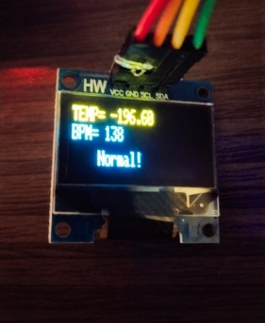

Fig. 3. Monitor and display victim’s current scenario

Fig. 4. In case of an emergency, when pressing the emergency switch, the saved contacts will receive this message along with the location link.

Fig. 5. Live location of person

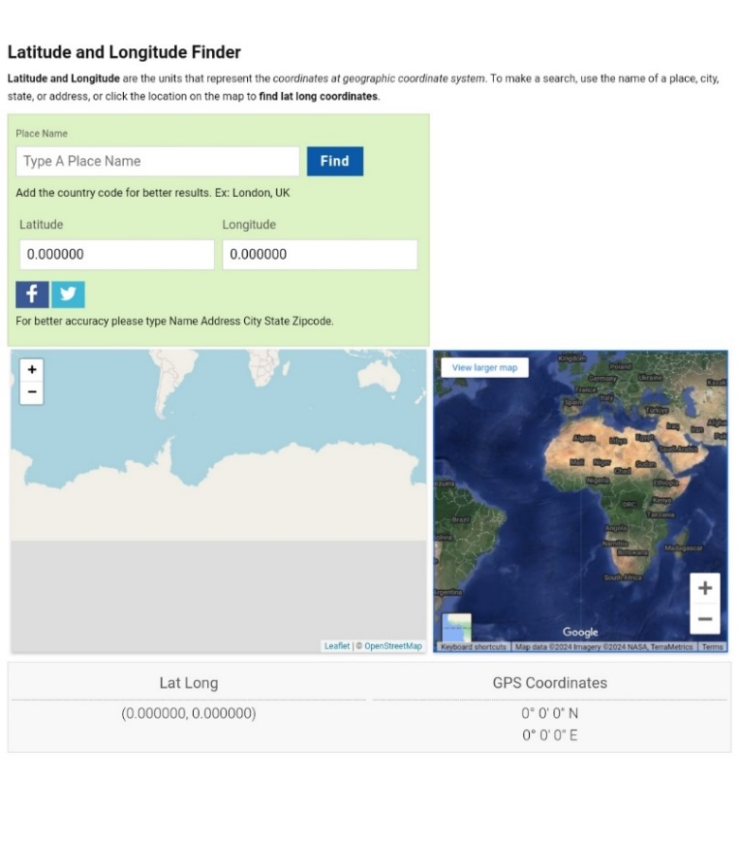

Fig. 6. Output terminal of map

**IX. FUTURE SCOPE**

Future demand for women's safety gadgets will likely need them to be small, inexpensive, and have simple-to-follow instructions, given the popularity of past devices and apps. containing every protective feature. Due of a higher incidence of physical abuse incidents, women residing in rural regions should be the target audience for the new device. The gadget ought to be made so that it provides the woman's guardian with 100% accurate information regarding harm. However, it has been observed that even devices trained with machine learning are not 100% correct. Hence, additional prediction sets need to be run on the devices. Without requiring human assistance, a new system that includes self-defense capabilities must be created. The arrangement ought to Future demand for women's safety gadgets will likely need them to be small, inexpensive, and have simple-to-follow instructions, given the popularity of past devices and apps.

# **X. CONCLUSION**

Women's wearable safety devices that make use of IoT and machine learning technology have become useful instruments for improving personal safety. Through the use of IoT connectivity, these gadgets are able to link wearable sensors to the internet, enabling real-time alerting and monitoring. They provide covert and unobtrusive safety monitoring by identifying anomalous behavior or circumstances that might point to possible hazards. Continuous monitoring and quick reactions to threats are made possible by integration with machine learning. Subsequent enhancements might concentrate on creating more sophisticated machine learning algorithms, strengthening connectivity with smart home devices, extending battery life and robustness, and boosting user interface and experience. In general, these gadgets present encouraging opportunities to improve women's safety, and they may be improved further to further cement their position as indispensable safety instruments.

# **REFERENCES**

1. G C Harikiran, Karthik Menasinkai and Suhas Shirol, "Smart Security Solution for women based on Internet of Things(IOT)", International Conference on Electrical Electronics and Optimization Technique IEEE, 2016.
2. Abhijit Paradkar and Deepak Sharma, "All in one Intelligent Safety System for women security", International Journal of computer applications, vol. 130, no. 11, November 2015.
3. Divya Chitkara, Nipun Sachdeva and Yash Dev Vashisht, "Design of a women safety device" in , IEEE, 2017.
4. A.P. Thaware, "Safety device for women’s security using GSM/GPS", International Journal on Recent and innovation trends in computing and communication, vol. 5, no. 4, pp. 5-7, 2017.
5. Empowerment towards developing India", IEEE Conference in Humanitarian Technology Conference, pp. 1-6, 21-23 Dec 2016.
6. G C Harikiran, Karthik Menasinkai and Suhas Shirol, "Smart Security Solution for Women based on Internet of Things(IOT)" in , IEEE, pp. 3551-3554, 2016.
7. G Toney, F Jaban, S. Puneeth et al., "Design and implementation of safety arm band for women and children using ARM7", 2015 International Conference on Power and Advanced Control Engineering (ICPACE), pp. 300-3, 2015 Aug 12-14.
8. Vigneshwari S and Aramudhan M, "Social information retrieval based on semantic annotation and hashing upon the multiple ontologies", Indian Journal of Science and Technology., vol. 8, no. 2, pp. 103-7, Jan 2015.